1. The user creates an internal transfer and add’s “the from” and “to storers”. Then on the first line, selects the item that needs to be transferred. The user clicks on the item that needs to be transferred, and the item and it’s details are automatically populated in line1 i.e. the “from” and “to” details. The user then clicks on “Save”

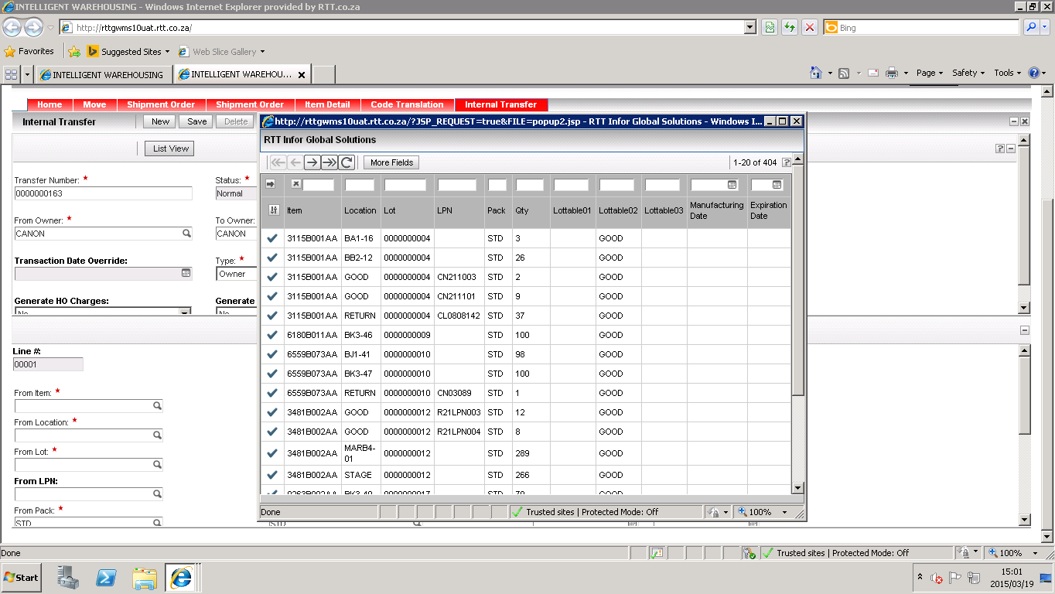

1. If the user clicks on “New” on the detail of the transfer to add the second line. 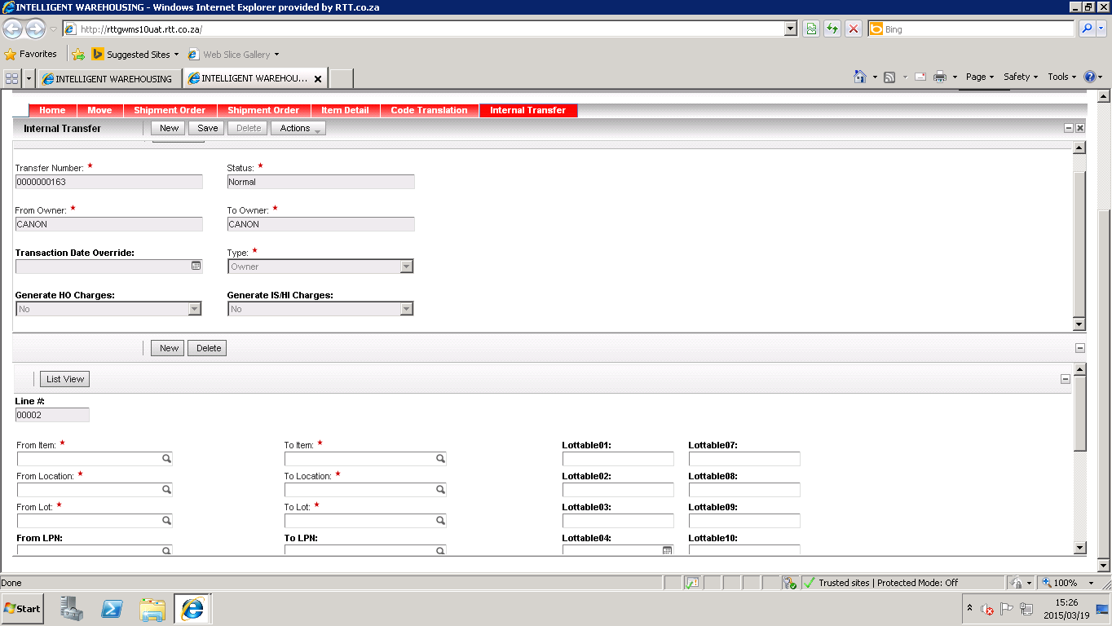
2. The user is then selects the “From Item” to populate the details of the new record.

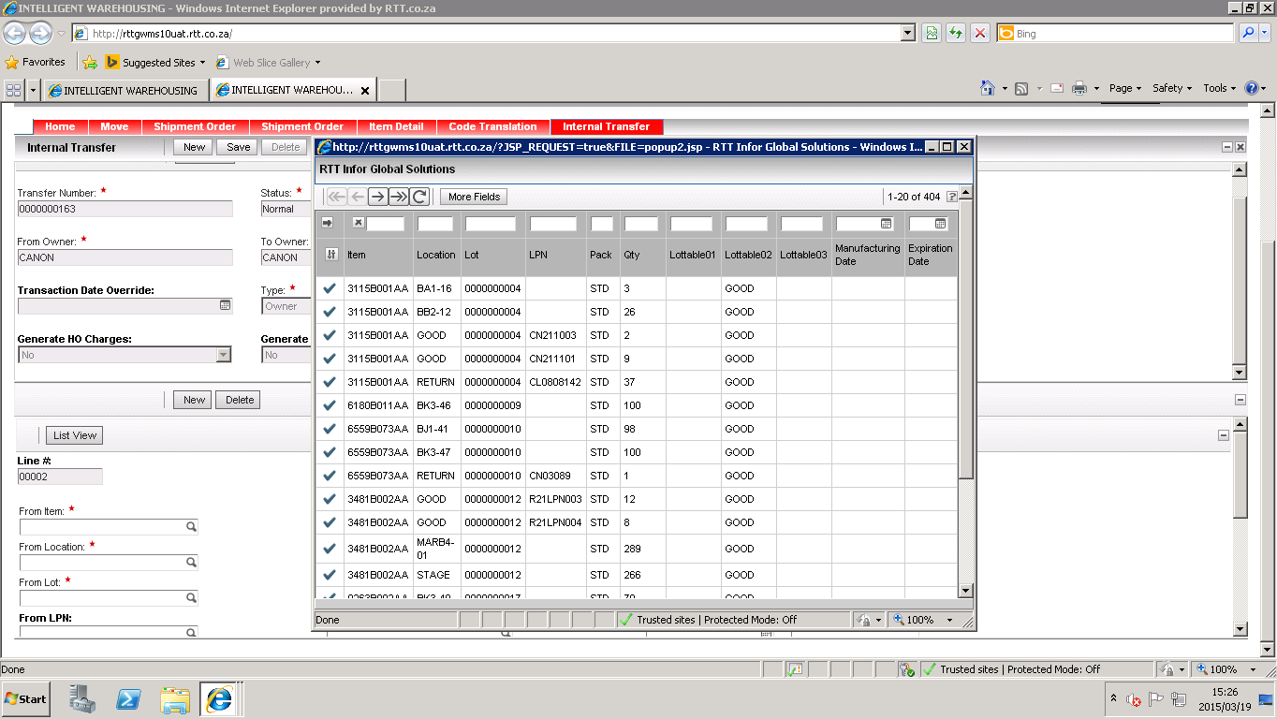

1. Once the user selects the specific record, the following error is displayed. Note: If the user adds the details manually the on the line the transfer accepts the details.

